Software Design Document
for Amber AI Assistant
Version 1.0 (Approved)
Prepared by:
Braedon Edison, Alejandro Urbano, Luciano Aldana, Gavin Chan, Christian Perez,
Isaiah Villalobos, Luis Vicente Cruz, Leonardo Pahtle Quechol, Ira Vizcarra,
Benjamin Saucedo, Astrid Zepeda
Organization: Amber Molecular Dynamics
Date: 11/5/2025

1. Introduction
1.1 Purpose
This Software Design Document (SDD) defines the functional and non-functional requirements and design specifications for the Amber Retrieval-Augmented Generation (RAG) System, Version 1.0.
The system is designed to ingest, process, embed, and semantically retrieve knowledge from Amber Molecular Dynamics (MD) mailing lists and tutorial documentation.
1.2 Document Conventions
This document follows standard software documentation conventions:
- Section headers are bolded.
- Functional requirements are labeled as FR-x.
- Non-functional requirements are labeled as NFR-x.
- Important system terms such as User, Admin, Thread-Level JSON, Embedding, and Vector Database are capitalized for clarity.
- All requirements statements use the word 'shall' to indicate mandatory behavior.
1.3 Intended Audience and Reading Suggestions
This document is intended for:
- Developers - To implement the system.
- Project Managers - To track scope and development milestones.
- Faculty Advisors & Evaluators - To assess technical completeness.
- Testers - To validate system functionality.
- Future Maintainers - To understand long-term system behavior.
Recommended Reading Order: Section 1 Introduction (high-level understanding), Section 2 Design Considerations (constraints and assumptions), Functional Requirements, Non-Functional Requirements, and System Architecture & Data Flow.
1.4 System Overview
The Amber RAG System is an online, automated knowledge retrieval platform that transforms decades of Amber MD mailing-list discussions and tutorials into a searchable AI-powered assistant.
The system scrapes raw HTML data from the Amber archives, parses it into structured JSON, merges messages into thread-level documents, and generates vector embeddings using the MiniLM-L6-v2 model. Embeddings are stored in a local ChromaDB vector database using a DuckDB + Parquet backend. All tasks including scraping, validation, ingestion, and monitoring are orchestrated using Apache Airflow.
The system provides:
- A User Interface for natural-language semantic search.
- An Admin Interface for manual queries, data cleanup, and metadata correction.

2. Design Considerations
2.1 Assumptions and Dependencies
The Amber RAG System is designed to operate locally within a high-performance computing (HPC) or standard Linux server environment. It assumes periodic internet accessibility to fetch remote archive updates, though it must operate entirely offline once the vector database is fully seeded.
2.2 General Constraints
The design of the system is constrained by the following factors:
- Hardware Constraints: The system must run on both GPU-enabled and CPU-only machines.
- Data Storage Constraints: All vector data must be stored locally using ChromaDB with DuckDB + Parquet.
- Performance Constraints: Daily ingestion and embedding updates must complete within acceptable processing windows.
- Network Constraints: The pipeline must tolerate intermittent network access to the Amber archive.
- Interoperability Constraints: The system must support future expansion for additional document sources beyond the Amber mailing list.
- Verification & Validation Constraints: All ingested documents must pass schema validation before embedding.
2.3 Goals and Guidelines
- The system shall follow the KISS (Keep It Simple, Stupid) principle.
- The system shall prioritize reliable performance over aggressive memory optimization, ensuring that daily operations and embedding tasks complete within acceptable time frames.
- The system interface shall follow the design patterns of existing AI chat assistants, ensuring ease of use and minimal user learning curve.
2.4 Development Methods
The Amber AI Assistant was developed using an Agile-focused development methodology. At the beginning of each week, tasks were assigned to team members based on project priorities and system needs. Each individual was responsible for prioritizing the components of their assigned tasks and determining the most effective order of implementation.
Development followed an iterative cycle of implementation, testing, and refinement, allowing the team to continuously improve system functionality while adapting to evolving technical requirements. This approach enabled rapid debugging, flexible feature expansion, and steady progress toward project milestones.

3. Architectural Strategies
3.1 Choice of Programming Language and Runtime Environment
The system is implemented primarily in Python.
Reasoning:
- Strong ecosystem for data processing, web scraping, and machine learning.
- Mature libraries for HTTP requests, HTML parsing, JSON processing, and scheduling.
- Widely used in scientific computing environments, aligning with the Amber user community.
Alternatives Considered:
- C++/Java were considered for performance, but rejected due to slower development speed and less convenient ML tooling.
- Node.js was considered for the UI layer but was unnecessary for the initial offline-focused version; simplicity and reduced stack complexity were prioritized.
3.2 Data Storage and Vector Database Strategy
The system uses ChromaDB with a DuckDB + Parquet backend as the primary vector store for semantic retrieval.
Reasoning:
- ChromaDB provides simple APIs for storing embeddings and metadata.
- DuckDB + Parquet offers lightweight, file-based storage suitable for local, offline environments.
- Good balance between performance, simplicity, and portability.
Alternatives Considered:
- PostgreSQL with pgvector or other self-hosted vector DBs were considered but rejected due to increased operational complexity and setup overhead.
- Cloud vector databases (e.g., managed services) were rejected to preserve the offline-first, self-contained requirement.
3.3 Thread-Level JSON as the Core Data Abstraction
Raw mailing-list messages are parsed and merged into thread-level JSON files, where each file represents one discussion topic (original question + replies).
Reasoning:
- Aligns with how humans consume mailing-list information (entire threads instead of isolated messages).
- Simplifies embedding generation and retrieval by treating each thread as a coherent document.
- Makes it easier to debug and manually inspect data when needed.
Alternatives Considered:
- Storing each individual email as a separate document was rejected because it fragments context and can lead to low-quality retrieval.

3.5 Embedding Model Selection
The system uses a Sentence-Transformers MiniLM-L6-v2 style model for generating embeddings.
Reasoning:
- Good trade-off between accuracy and computational cost.
- Small enough to run on CPU-only systems while still producing meaningful semantic embeddings.
- Widely used and well-documented, simplifying integration and troubleshooting.
Alternatives Considered:
- Larger transformer models were rejected for the offline version due to hardware requirements and slower inference.
- Very small models were rejected due to poor quality for Q&A tasks.
3.6 Use of Apache Airflow for Orchestration
The pipeline uses Apache Airflow to schedule and orchestrate scraping, parsing, validation, embedding, and ingestion tasks.
Reasoning:
- Airflow is a mature tool for workflow organization, with built-in support for scheduled runs, task dependencies/retries, and centralized logs.
- Enables future expansion with additional DAGs (e.g., tutorial ingestion, model refresh, incremental updates).
Alternatives Considered:
- Custom cron jobs and shell scripts were considered but rejected due to limited observability, poor error handling, and difficulty scaling as the pipeline grows.
- Other orchestrators (e.g., Prefect, Luigi) were considered but Airflow was chosen due to familiarity and widespread use in data engineering.
3.7 User and Admin Interface Paradigm
The system defines two conceptual interfaces:
- User Interface: Focused on natural-language question answering, abstracting away internal details like thread IDs.
- Admin Interface: Allows manual queries, data inspection, metadata correction, and orchestration control.
Reasoning: Separating User vs Admin workflows reduces accidental misuse, keeps the main experience simple, and supports long-term maintainability by giving admins tools to fix data issues without editing low-level files.

4. System Architecture
This section provides a high-level overview of how the Amber RAG System is organized into major subsystems and how they collaborate to provide the required functionality. The system follows a modular, pipeline-based architecture, where data flows through clearly separated stages from ingestion to retrieval.
4.1 Top-Level View (Level 0)
At the highest level, the Amber RAG System acts as an offline knowledge assistant between external data sources and users. It collects Amber mailing-list and tutorial data from public archives, processes and stores this information locally in a vector database, and answers user questions by performing semantic search over the stored knowledge.
The main external actors are:
- User - Asks natural-language questions and receives retrieved answers.
- Admin - Manages system health, data quality, and maintenance tasks.
- Amber Archive Website / Tutorials Site - Public data sources that provide raw content.
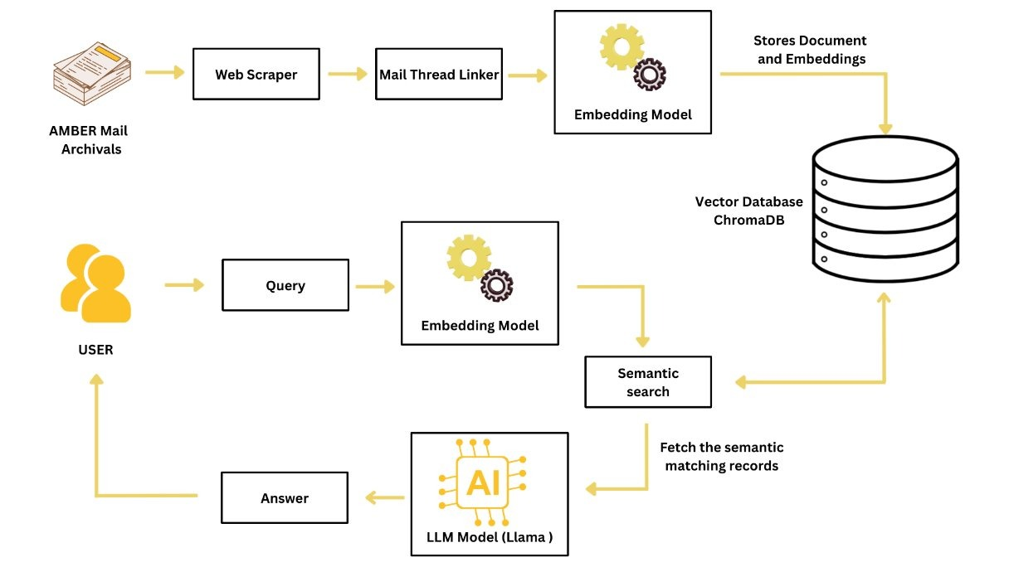
4.2 Major Subsystems (Level 1)
Internally, the system is decomposed into the following major subsystems:
- 1. Data Ingestion Subsystem: Scrapes and downloads raw HTML pages and other source documents from the Amber archives.
- 2. Parsing & Structuring Subsystem: Converts raw HTML into structured JSON and groups individual emails into thread-level documents.
- 3. Validation & Cleaning Subsystem: Checks that each JSON document matches the expected schema and filters out malformed or corrupted data.
- 4. Embedding Generation Subsystem: Uses an embedding model (e.g., MiniLM-L6-v2) to convert thread-level documents into vector representations.
- 5. Vector Storage Subsystem: Stores embeddings and metadata in ChromaDB (DuckDB + Parquet backend).
- 6. Query & Retrieval Subsystem: Accepts user questions, embeds the query, performs semantic search, and returns ranked results.
- 7. Administration & Monitoring Subsystem: Allows admins to inspect data, run manual queries, and review pipeline logs.
- 8. Workflow Orchestration Subsystem (Airflow): Schedules runs, manages task dependencies, retries, and logging.

5. Policies and Tactics
5.1 Choice of Specific Products Used
- Programming Language: Python 3.10+
Chosen for rapid development, strong data-processing libraries, and wide ML support. (Alternative rejected: No alternates were considered; this decision was determined beforehand by the staff.)
- Workflow Orchestration: Apache Airflow
Used for scheduling scraping, ingestion, and validation pipelines. (Alternative rejected: Cron jobs were rejected due to weak error handling and logging.)
- Vector Database: ChromaDB
Used to store embeddings and metadata locally. (Alternative rejected: PostgreSQL + pgvector was rejected due to added configuration and operational complexity.)
- Storage Backend: ChromaDB, DuckDB + Parquet
Chosen for fast local analytics and portability. (Alternative rejected: Traditional SQL databases were unnecessary for file-based offline storage.)
- Embedding Library: Sentence-Transformers (MiniLM-L6-v2)
Selected for strong performance with low computational cost. (Alternative rejected: Larger transformer models were rejected due to hardware limitations.)
- Development Environment / IDE: VS Code
Chosen for Python debugging, Git integration, and extension support.
5.2 Plans for Ensuring Requirements Traceability
Requirements traceability is maintained through the following methods:
- Each task is assigned a title to be tracked.
- Airflow tasks, pipeline scripts, and test cases explicitly reference the corresponding requirement name.
- Git commit messages reference relevant requirements when features are added or modified.
This ensures that every requirement is verifiably implemented, no implemented feature lacks a corresponding requirement, and system changes can be audited.
5.3 Plans for Testing the Software
- Unit Testing: Individual components such as parsers, validators, and embedding generation are tested in isolation.
- Integration Testing: Entire pipeline stages are executed sequentially (Scraping ➔ Parsing ➔ Validation ➔ Embedding ➔ Storage).
- System Testing: The full Airflow pipeline is executed under realistic operating conditions. User queries are executed against the populated database.
- Regression Testing: After any code modification, previous ingestion and query tasks are rerun to ensure no failures occur.

6. Detailed System Design
6.1 Data Ingestion Subsystem
6.1.1 Responsibilities
Retrieves raw Amber mailing-list HTML and tutorial content. Handles scheduled and manual downloads. Stores raw files locally.
6.1.2 Constraints
Requires network access during scraping. Must tolerate failures and avoid duplicate downloads. HTML structure may change.
6.1.3 Composition
HTML fetcher, URL queue, local storage handler.
6.1.4 Uses / Interactions
Uses Amber Archive Website. Sends raw HTML to Parsing & Structuring. Controlled by Airflow.
6.1.5 Resources
Network, disk storage, CPU.
6.1.6 Interface / Exports
  - populateCleanData(year_key, month_key)
6.2 Parsing & Structuring Subsystem
6.2.1 Responsibilities
Converts HTML to JSON. Extracts metadata. Merges messages into thread-level documents.
6.2.2 Constraints
Input must be valid HTML. Output must follow JSON schema.
6.2.3 Composition
HTML parser, metadata extractor, thread merge logic.
6.2.4 Uses / Interactions
Receives HTML from Ingestion. Sends JSON to Validation.
6.2.5 Resources
CPU, memory, temporary storage.
6.2.6 Interface / Exports
extract_body_text()
6.3 Validation & Cleaning Subsystem
6.3.1 Responsibilities
Validates schema. Detects and filters corrupted data.
6.3.2 Constraints
All required fields must exist. Invalid data must never reach storage.
6.3.3 Composition
Schema validator, rule-based filters, quarantine handler.
6.3.4 Uses / Interactions
Receives JSON from Parsing. Sends verified data to Embedding. Logs errors.
6.3.5 Resources
Memory, disk storage.
6.3.6 Interface / Exports
  - _validate_metadata(dict), clear_collection()

6.4 Embedding Generation Subsystem
6.4.1 Responsibilities
Generates vector embeddings from validated documents. Supports CPU and optional GPU.
6.4.2 Constraints
Must be deterministic. Model must be locally stored.
6.4.3 Composition
Model loader, batch processor.
6.4.4 Uses / Interactions
Receives data from Validation. Sends vectors to Vector Storage.
6.4.5 Resources
CPU/GPU, RAM, model files.
6.4.6 Interface / Exports
  - add_json(json_input)
6.5 Vector Storage Subsystem (ChromaDB)
6.5.1 Responsibilities
Stores embeddings and metadata. Supports similarity search.
6.5.2 Constraints
Must persist across restarts. Only validated vectors allowed.
6.5.3 Composition
ChromaDB client, DuckDB backend, Parquet files.
6.5.4 Uses / Interactions
Receives vectors from Embedding. Serves results to Query Subsystem.
6.5.5 Resources
Disk I/O, memory.
6.5.6 Interface / Exports
  - add_documents(vectors, metadata), query_embeddings(query_vector, k), delete_record(id)
6.6 Query & Retrieval Subsystem
6.6.1 Responsibilities
Accepts user queries. Embeds queries and retrieves results. Returns ranked output.
6.6.2 Constraints
Must meet real-time latency. Must use same embedding model as ingestion.
6.6.3 Composition
Query embedding engine, ranking engine, response formatter.
6.6.4 Uses / Interactions
Receives user input. Queries Vector Storage.
6.6.5 Resources
CPU, memory.
6.6.6 Interface / Exports
  - query(query_text, threshold)

6.7 Administration & Monitoring Subsystem
6.7.1 Responsibilities
Manual inspection, query execution, re-ingestion, and monitoring.
6.7.2 Constraints
Restricted to authorized admins. Audit logging required.
6.7.3 Composition
Admin dashboard, log viewer, manual trigger tools.
6.7.4 Uses / Interactions
Interfaces with all subsystems. Controlled through Airflow.
6.7.5 Resources
UI resources, log storage.
6.7.6 Interface / Exports
  - Not made
6.8 Workflow Orchestration Subsystem (Airflow)
6.8.1 Responsibilities
Schedules pipeline runs. Controls task order and retries. Logs execution.
6.8.2 Constraints
Requires scheduler uptime. Failures must not corrupt data.
6.8.3 Composition
DAG scheduler, Python operators, logging system.
6.8.4 Uses / Interactions
Controls all pipeline subsystems.
6.8.5 Resources
CPU, memory.
6.8.6 Interface / Exports
  - Run via web host (AIRFLOW)
7. Detailed Lower Level Component Design
7.1 Scraper and Parser Joiner Module (joiner.py)
7.1.1 Classification
File / Data Ingestion and Processing Module
7.1.2 Processing Narrative (PSPEC)
Controls the full data ingestion and parsing workflow by calling the scraper to download raw Amber archive HTML and then immediately passing the output to the parser to generate structured JSON files.
7.1.3 Interface Description
  - get_data()
7.1.4 Processing Detail
Standalone procedural control module. Requires stable internet during scraping. Scraping and parsing must execute sequentially.

7.2 Vector Database Interface (database_api.py)
7.2.1 Classification
File / Database Interface Layer
7.2.2 Processing Narrative (PSPEC)
Stores vector embeddings and metadata in ChromaDB and provides similarity search functionality.
7.2.3 Interface Description
  - add_documents(vectors, metadata), query_embeddings(query_vector, k), delete_record(id)
7.2.4 Processing Detail
Abstract database wrapper. Requires active ChromaDB backend. Only schema-valid vectors are permitted.
7.3 Administration & Monitoring Module
7.3.1 Classification
Conceptual Subsystem
7.3.2 Processing Narrative (PSPEC)
Allows manual inspection, execution, and resets of system state through controlled operations.
7.3.3 Interface Description
  - Not made
7.4 Workflow Orchestration Script (Airflow DAG)
7.4.1 Classification
File / Workflow Control Script
7.4.2 Processing Narrative (PSPEC)
Controls the scheduled execution of scraping, parsing, embedding, and vector storage tasks.
7.4.3 Interface Description
  - Run via web host
8. Database Design
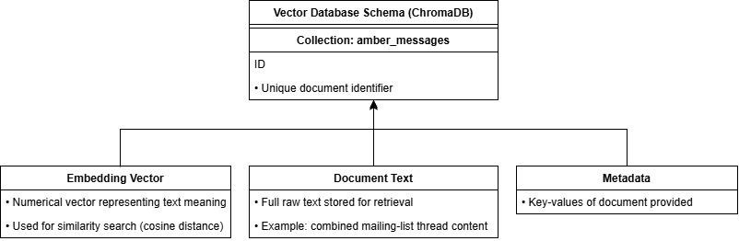
8.1 Database Type
Vector database with embedded analytical storage backend.
- Primary Database Engine: ChromaDB
- Metadata Backend: DuckDB
- Vector Storage Format: Parquet files
8.2 Database Purpose
Store vector embeddings and metadata generated from Amber mailing-list threads while supporting fast similarity search and persistence across system restarts.
8.3 Logical Data Model
Each stored record represents one thread-level Amber discussion document containing: Unique document ID, vector embedding, thread metadata, and original thread text.
NOTE: In a vector database, there is only 1 table or collection, different from a traditional relational database.

9. User Interface
  - N/A
9.1 Overview of User Interface
  - N/A
9.2 Screen Frameworks or Images
  - N/A
9.3 User Interface Flow Model
  - N/A

10. Requirements Validation and Verification
ID | Description | Involved Modules | UI Elements | Verification / Test Method
FR-1 | The system shall scrape Amber mailing list data for ingestion. | Scraper & Parser Joiner Module, Airflow DAG | None | Run scrape_month(link) and verify that HTML files are downloaded.
FR-2 | The system shall convert raw HTML into structured JSON. | Scraper & Parser Joiner Module | None | Execute parse(input_file, output_file) and inspect JSON output for schema correctness.
FR-3 | The system shall store vector embeddings and metadata persistently. | Vector Database Interface (database_api.py) | None | Insert test records using add_documents and verify persistence after restart.
FR-4 | The system shall allow users to submit natural-language queries. | Query & Retrieval Subsystem | Main Query Screen (N/A) | Enter a test query and verify that input is accepted.
FR-5 | The system shall return ranked semantic search results. | Query & Retrieval Subsystem, Vector Storage Subsystem | Results Display Screen (N/A) | Submit known queries and verify ranked results against expected relevance.
FR-6 | The system shall allow administrators to monitor and manage ingestion tasks. | Administration & Monitoring Subsystem, Airflow DAG | Admin Monitoring Screen (N/A) | Trigger a pipeline run and verify task status in Airflow UI.
FR-7 | The system shall execute ingestion automatically on a schedule. | Workflow Orchestration Subsystem (Airflow) | None | Verify DAG triggers at scheduled time and completes successfully.
FR-8 | The system shall support deletion of stored records. | Vector Database Interface | Admin Monitoring Screen (N/A) | Call delete_record(id) and verify record removal via query test.
FR-9 | The system shall prevent invalid documents from being stored. | Scraper & Parser Joiner Module, Vector Database Interface | None | Attempt to insert malformed JSON and verify rejection.
FR-10 | The system shall display original source links for retrieved results. | Query & Retrieval Subsystem, Vector Storage Subsystem | Results Display Screen (N/A) | Verify returned results include valid Amber archive URLs.

11. Glossary
Term | Definition
Admin | An authorized user responsible for monitoring, maintaining, and managing the Amber RAG System, including re-ingestion, logs, and pipeline status.
Amber | A suite of biomolecular simulation programs used for molecular dynamics (MD) simulations. Also refers to the Amber user community.
Amber Archive | The public mailing-list archive where Amber users post questions, bug reports, and solutions. This is the primary data source for the system.
ChromaDB | A local vector database used to store embeddings and metadata and to perform similarity search over embedded documents.
DAG (Directed Acyclic Graph) | A workflow model used by Airflow to define tasks and their dependencies with no cyclic paths.
DuckDB | An embedded analytical database used by ChromaDB as a metadata backend.
Embedding | A numeric vector representation of text that captures semantic meaning for similarity comparison.
JSON (JavaScript Object Notation) | A text-based data format used for storing structured data as key-value pairs and arrays.
Mirzakhani | The server or HPC environment where the Amber RAG System is deployed and executed.
RAG (Retrieval-Augmented Generation) | A system pattern where relevant documents are retrieved first and then used to support or improve generated answers.
Thread-Level JSON | A JSON document that represents an entire Amber mailing-list discussion thread as one structured unit.
Vector Database | A database optimized for storing and querying high-dimensional vector embeddings for similarity search.
Workflow Orchestration | The process of scheduling and managing ordered tasks in a pipeline using Airflow.

12. References
Title | Version / Date / Author | Source / Location
Amber SRS | Project Team (Current Version) | Internal project document
Software Design Document Template | Brad Appleton (Not specified) | brad@bradapp.net, http://www.bradapp.net
CS 307 Example Design Template (Fall 2008) | Purdue University (Fall 2008) | https://www.cs.purdue.edu/homes/cs307/ExampleDocs/DesignTemplate_Fall08.doc
Amber Molecular Dynamics Documentation | Amber Development Team (Current) | The Amber Molecular Dynamics Package
Apache Airflow Documentation | Apache Software Foundation (Current) | Apache Airflow Official Docs
ChromaDB Documentation | ChromaDB Team (Current) | Introduction - Chroma Docs
Sentence-Transformers Documentation | Hugging Face (Current) | Hugging Face - The AI community building the future.

